Face Recognition Based Attendance Monitoring System

**Abstract— Monitoring attendance is a crucial responsibility in educational and organizational environments, yet it is often plagued by errors and inefficiencies. Our Attendance Monitoring System, which relies on face recognition, offers a dependable and automated answer to this issue. Utilizing OpenCV for face detection and recognition along with Tkinter for the GUI, our solution provides a user-friendly platform for administrators to manage attendance effectively. The system begins by capturing images of individuals' faces for registration purposes, subsequently employing the Haar cascade classifier to identify faces. Utilizing the LBPH (Local Binary Patterns Histograms) Face Recognizer, the system acquires the capability to identify individuals through their facial characteristics. At registration, users have the chance to establish a robust password to control access and preserve system integrity. Administrators can swiftly add, modify, or delete employees or students.**

I.INTRODUCTION

The need for effective attendance monitoring systems has never been higher in the ever-changing organizational and educational environments of today. Conventional approaches that depend on card-based systems or human data entry are becoming more and more viewed as laborious, prone to mistakes, and manipulable. Integrating cutting-edge technologies becomes essential as organizations and enterprises aim for increased automation, security, and accuracy in attendance tracking.

The necessity of an attendance monitoring system based on facial recognition: A modern, dependable, and strong solution—the Face Recognition Based Attendance Monitoring System—is clearly needed in light of these issues. This system offers an innovative approach to attendance monitoring by utilizing facial recognition technology. The days of labor-intensive verification procedures and manual attendance registers are long gone. Administrators may now rely on the smooth and precise recognition of people by their distinctive face traits. An attendance monitoring system based on facial recognition. Modern Methods for Managing Attendance: This system's core is a complex mix of hardware and software elements. Users may interact with the system with ease because to the user-friendly platform provided by Tkinter, a Python framework for graphical user interface development. OpenCV is an open-source computer vision package that complements Tkinter and forms the foundation for facial identification and detection

The Interaction between Efficiency and Technology: Tkinter and OpenCV work together to enable the Face Recognition Based Attendance Monitoring System to provide unmatched accuracy and efficiency. Whether they are tracking attendance in real time or enrolling new users, administrators may easily navigate through Tkinter's user-friendly interface. OpenCV’s smart algorithms make it easy to detect and recognize faces quickly and accurately, even in tough conditions like bad lighting or when faces are at different angles. This technology puts an end to issues like buddy punching, where someone marks attendance for someone else, ensuring the process is both secure and reliable.This precise verification of identities using unique facial features enhances security and accountability. It also promotes a culture of honesty and trust within the organization, making the Face Recognition-Based Attendance Monitoring System a groundbreaking innovation in attendance management.

## LITERATURE REVIEW

The reviewed literature provides a thorough examination of face recognition systems and technologies used for managing and tracking attendance, especially in institutional and corporate contexts. A variety of approaches, including biometric and RFID-based systems, are covered in this section to show how attendance control solutions have evolved and become more diverse. Various methodologies and technology frameworks are included in the works, which are carefully summarized to compare their effectiveness and show the changing trends in this field, which reflects ongoing improvements in attendance management technologies. Numerous research have examined various facets and obstacles associated with the use of face recognition technologies for attendance.

[1] uses facial recognition to investigate how attendance affects academic achievement, while [2] uses biometric attendance data to analyze the implications of absenteeism. The integration of SOAP-based services with RESTful services to enhance attendance systems is discussed in [3], and RFID and GSM-based systems are presented in [4] and [5], respectively, illustrating the integration of communication technologies with attendance tracking. These technological improvements are clear. [6], which makes use of Bluetooth technology, and [7], which concentrates on automated systems based on face recognition algorithms, both examine the development of mobile-based attendance systems. [8] and [9] investigate how web applications can improve data transfer, which can help real-time attendance systems. Comparative studies that examine various face identification techniques, as those in [10] and [11], improve the dependability of attendance systems. With [12]'s investigation of eigenfaces for recognition, a key idea in face recognition technology, the field's pioneering study continues. These technologies have been used in recent research such as [13] and [14] for particular purposes including edge computing environments and classroom attendance systems, respectively. [15] explores facial recognition security applications, expanding the use of attendance monitoring systems even more. Furthermore, network-based and wireless systems like those covered in [16], [17], and [18] demonstrate how biometric data can be integrated with contemporary network infrastructures to improve system efficiency and accessibility. [19] highlights the real-time processing capabilities of facial recognition systems, focusing on accuracy and performance improvements.

At last, demonstrating the potential of intelligent systems in educational settings, [20] details a clever attendance monitoring system that makes use of face recognition technology.   
All of these studies reveal a wide range of applications and advances in this developing sector, which helps to better comprehend technical advancements in facial recognition and attendance systems.

1. PROPOSED APPROACH

Developing a face recognition-based attendance monitoring system involves several key components to ensure accuracy and seamless functionality.

A:Designing User-Friendly Interfaces with Tkinter:The first step is to use Tkinter to build a simple, easy-to-use graphical interface. As Python’s built-in GUI toolkit, Tkinter offers a range of features for creating interfaces that anyone can navigate. By thoughtfully placing buttons, text fields, and labels, the design ensures that people of all technical skill levels can use the system without any hassle.

B: Using OpenCV to Implement Algorithms for Facial Detection and Recognition: To detect and recognize faces, the system uses OpenCV's robust capabilities. Pre-trained Haar cascade classifiers are available through OpenCV for facial recognition in images and video streams. The system will also use the LBPH algorithm for facial recognition, which will enable precise identification of people by their facial traits. 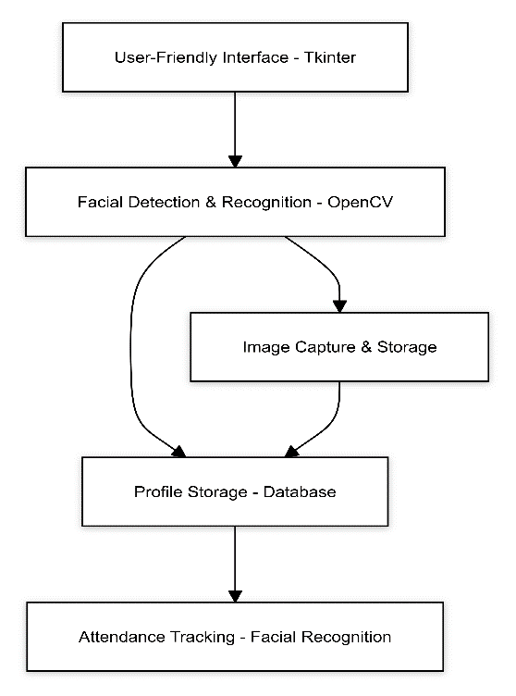

Fig.1. Flow chart

C: Development of a Database Management System for Profile Storage: A database management system will be created in order to effectively maintain employee or student profiles. Essential data, including names, IDs, and facial images, will be stored in a relational database schema. The use of CRUD activities will facilitate the smooth administration of profile data, guaranteeing data security and integrity via appropriate indexing and access control systems.

D: Integration of Facial Image Capture and Storage for Registration: During the registration procedure, the system will integrate the ability to take and save facial images. To extract facial features, camera capabilities will be used to acquire and preprocess facial images. Following processing, these images will be safely kept in the database along with the relevant profile data.

E: Creation of a Powerful Facial Recognition-Based Attendance Monitoring System: The system's primary function is the creation of a reliable facial recognition-based attendance tracking system. To match recorded facial images with database profiles, algorithms will be created. Attendance, together with timestamps and pertinent metadata, will be automatically recorded after successful identification. Accurate and dependable attendance tracking will be ensured by the system's ability to handle a variety of settings, such as several faces in the frame and difficult lighting.

**Distance Measure for Facial Feature Comparison.** The Local Binary Pattern Histogram (LBPH) algorithm converts facial features into histograms.

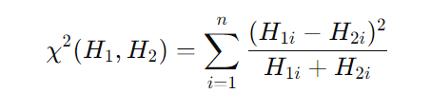

**Facial Recognition Confidence Score**: Given a captured facial image III and a stored profile PPP, the confidence score CCC can be defined as the inverse of the distance measure

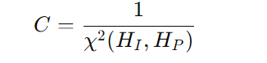

1. RESULTS AND ANALYSIS

## A web application is being developed for an attendance monitoring system that utilizes face recognition technolog. An open-source coding editor, a microweb framework, and a lightweight relational database management system for the backend are used in the implementation. In web development, the programming language is widely recognized for its ease of use and adaptability.

## **Face Recognition Attendance System Dash board**:

An attendance monitoring system that uses facial recognition has a graphical user interface that can handle both new registrations and current users. In addition to displaying the user's name and ID, the interface provides choices for recording attendance, viewing attendance history, and logging out of the system. New users can construct their profile by entering their name and ID, then taking images. Furthermore, the interface displays the total number of registrations made so far. By choosing options and filling in the appropriate forms, users engage with the system.

The below image shows the Dashboard page where the user needs to provide the username and id, after validating it allows to Take Images.

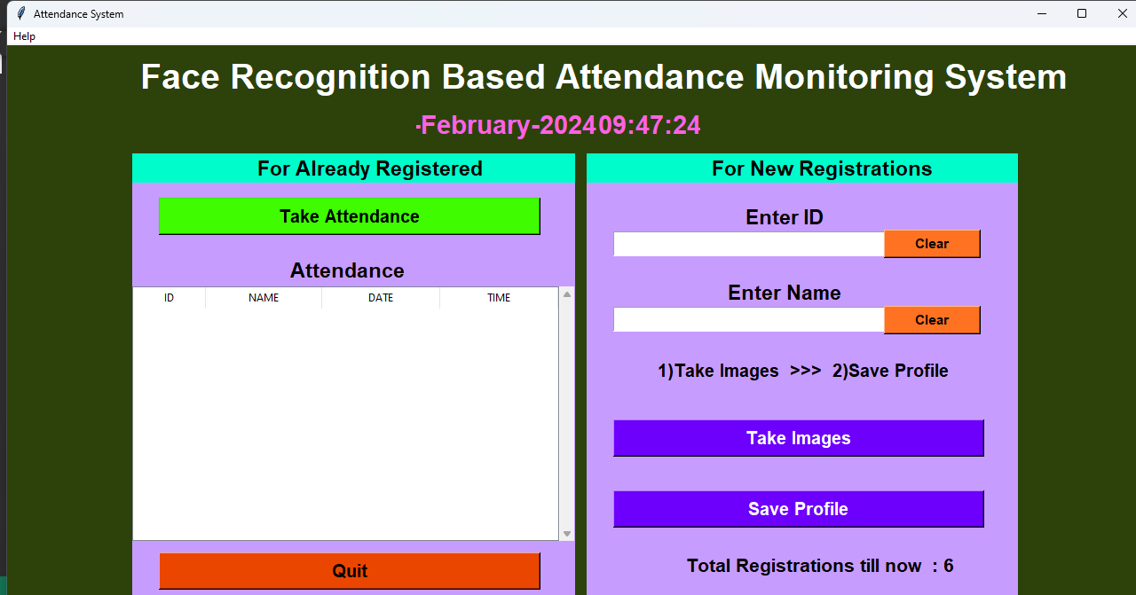

**New Registration - Enrolling in the System** :

The below image shows the Dashboard which consists New Registration section which will enroll the users.Once the images are captured and the profile is saved, users can seamlessly utilize the system for attendance management purposes.

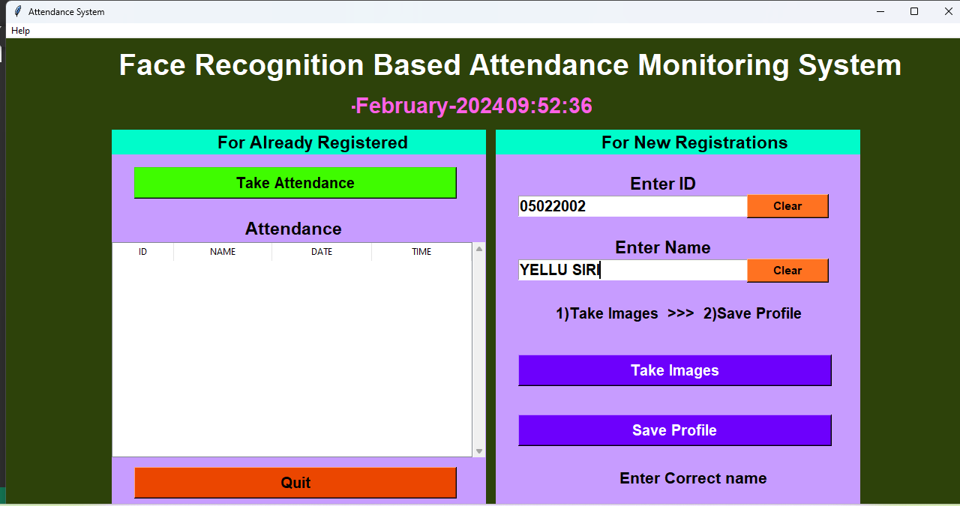

**Clicking on "Take Images":**  Upon clicking the "Take Images" option, users initiate the process of capturing facial images to create their profile. This action triggers the system to activate the camera for image acquisition.

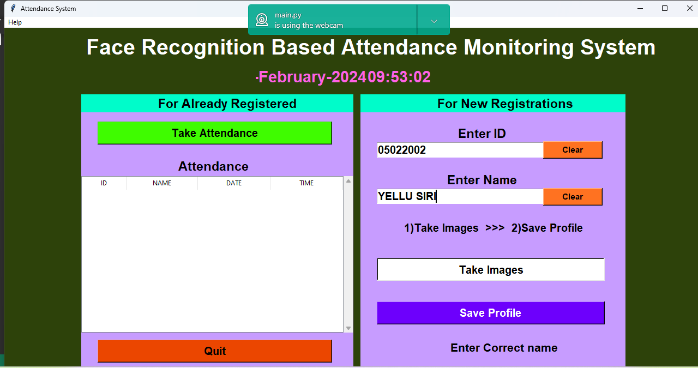



## **Profile Image Acquisition:**

When users click on the "Take Images" button, the system enters profile image acquisition mode. This prompts the webcam to capture facial images of the user. The captured images are then utilized to generate the user's profile within the attendance system.

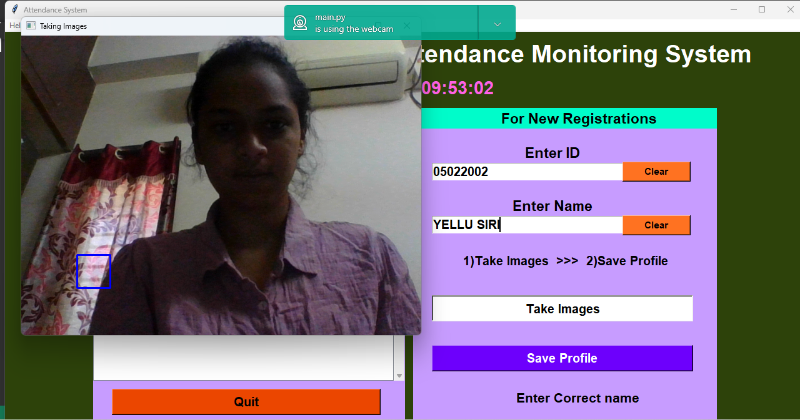

## **Image Capture Confirmation:**

The message "Images Taken for ID: 05022002" confirms successful image capture and storage for the individual with the specified ID. This occurs post-registration, where users enter their details and capture images. The system then saves these images to the individual's profile for future face recognition-based attendance. Additionally, users can take attendance, view reports, or exit the program

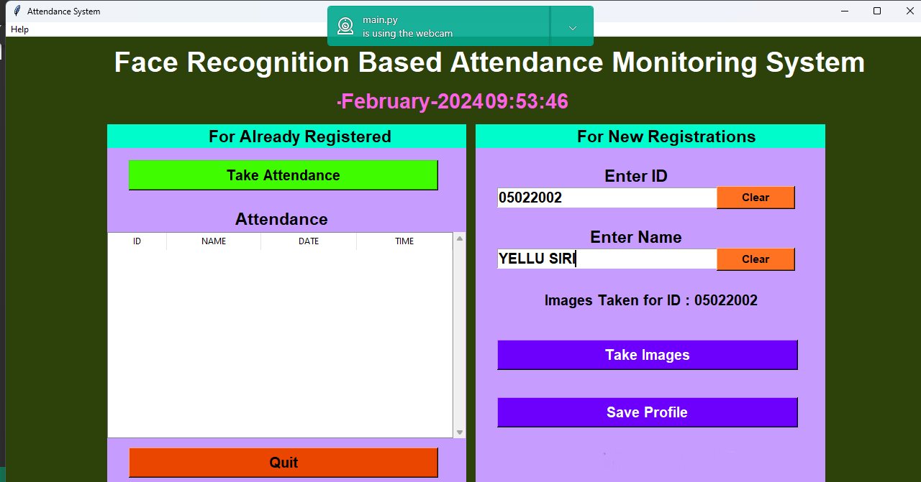

## **Profile Saving Confirmation**:

Clicking "Save Profile" in this attendance monitoring system saves the individual's information and images to the database. The system confirms successful image saving with a message like "Images Taken for ID: 05022002". Alongside the current date, time, and latest individual's name, users can manage attendance, view reports, or exit.

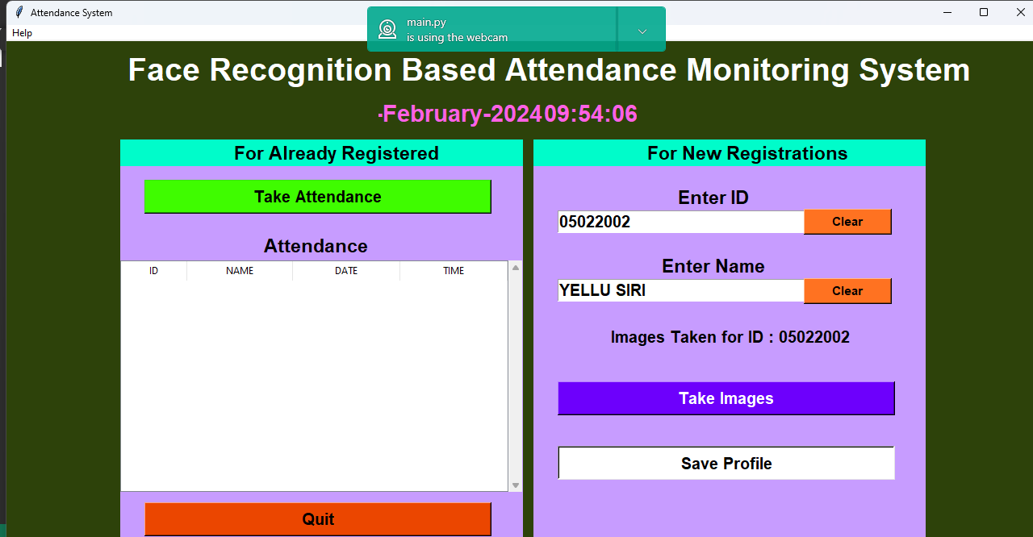

## **Password Entry Prompt:**

“Enter Password" prompts users to input their password for authentication. Users can submit by pressing "OK" or exit with "X" or "Cancel".

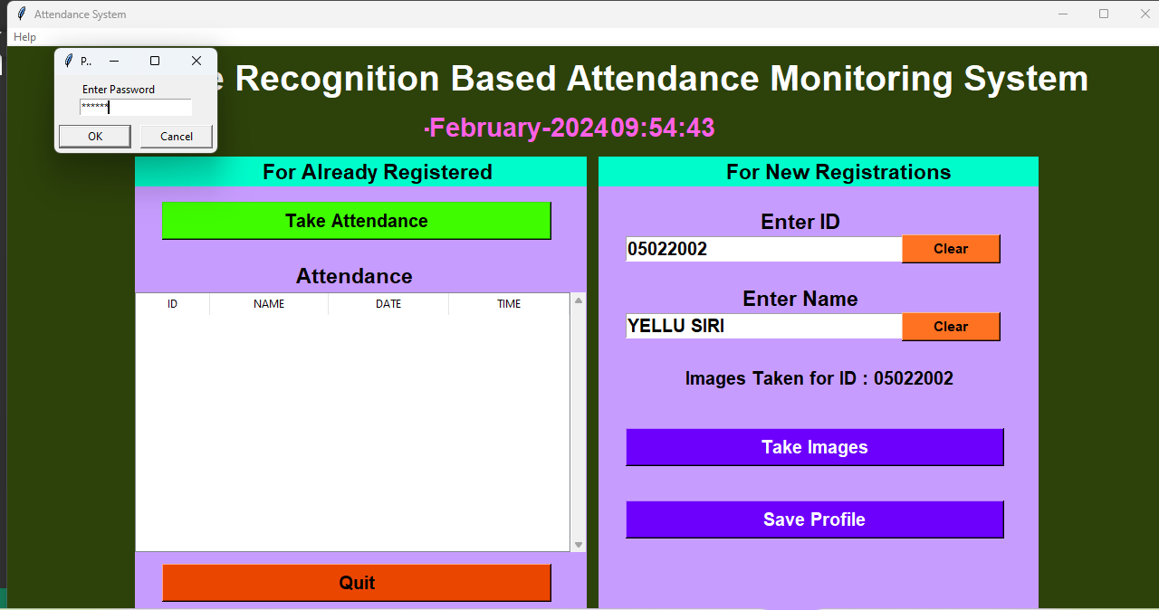

## **Registration Confirmation:**

"Profile Saved Successfully" confirms successful registration of a new person in the system. It assures users that the information has been stored correctly, enabling them to use the attendance system effectively.

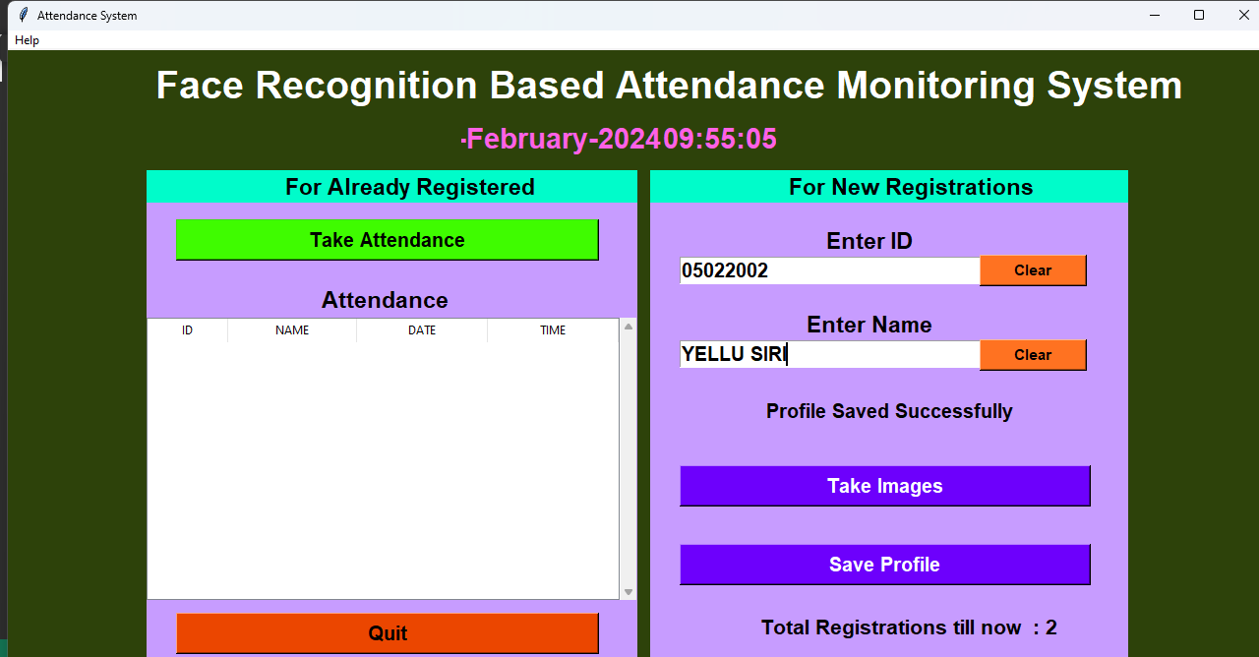

## **Attendance Tracking with Face Recognition :**

After successful registration, users can initiate attendance tracking by selecting "Take Attendance." The system timestamps the attendance session and prompts users to position individuals for face capture. Matching faces against stored profiles, the system marks attendance.

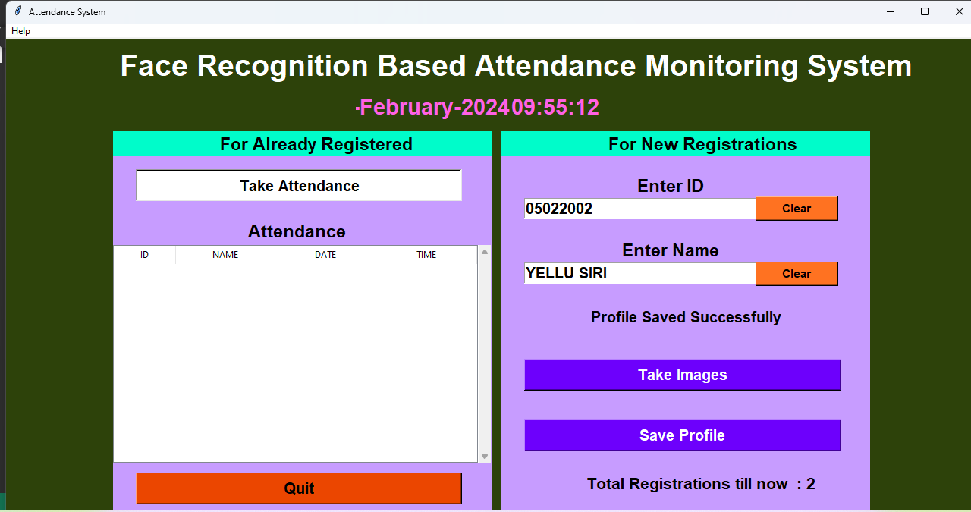

**Integrated Name and Face Identification in Attendance Tracking:**

During attendance taking, the system combines name and face identification. Upon selecting "Take Attendance," the webcam activates, displaying live footage. Users position individuals for face capture, and the system compares the image against stored profiles. Upon a match, the person's name and ID are displayed, ensuring accurate attendance tracking. This integrated approach enhances accuracy and efficiency, mitigating errors associated with manual methods.

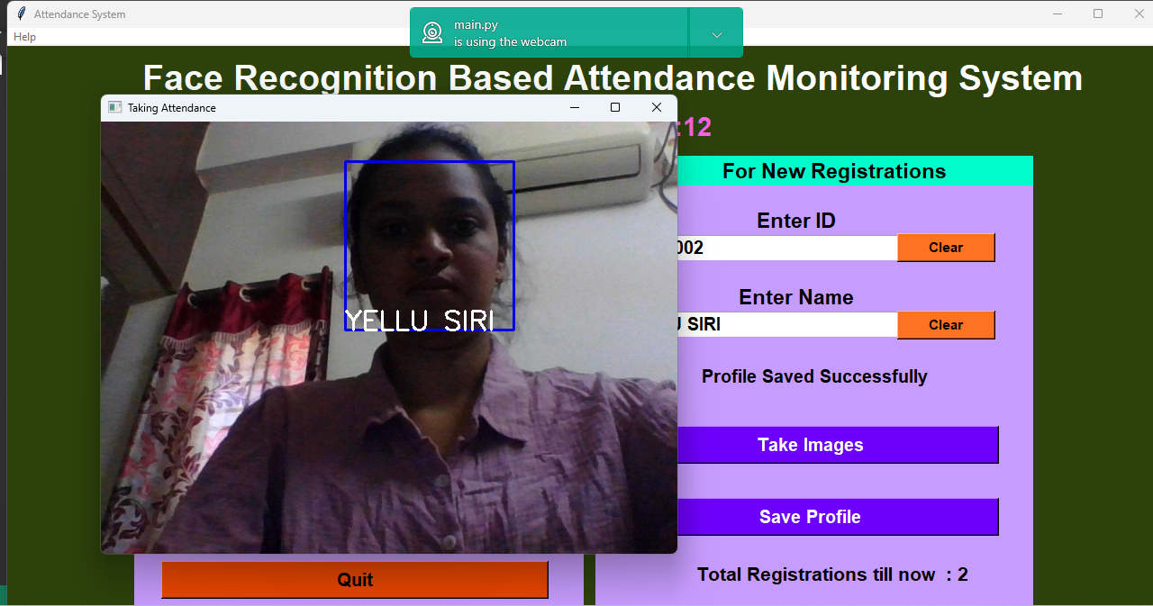

**Attendance Recording in Face Recognition System:**

The system stores IDs, names, dates, and times for attendance recording. Upon face recognition, attendance data including ID, name, date, and time is logged. The system maintains a record of registrations and displays total counts.

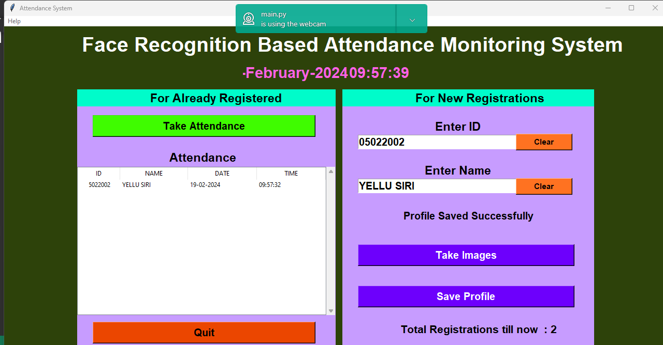

## CONCLUSION AND FUTURE WORK

In the end, we have successfully created and deployed a complete solution for attendance tracking using facial recognition technology by utilizing a combination of state-of-the-art technologies and sophisticated algorithms. In terms of attendance tracking technology, our Face Recognition Based Attendance Monitoring System is a major breakthrough. We have developed a comprehensive solution that meets the many demands of contemporary enterprises by fusing solid data storage, facial recognition for accuracy, encryption for confidentiality, and an intuitive online application for accessibility. The outcomes attained demonstrate how effective the solution was.

**Facial Recognition:**

Our attendance monitoring system's foundation is the incorporation of facial recognition technology. With the help of deep learning frameworks like TensorFlow or PyTorch for training convolutional neural networks (CNNs) and OpenCV for image processing, our system can reliably identify people in real time. We guarantee smooth and effective attendance tracking without requiring personal intervention by putting cutting-edge facial detection and identification algorithms into practice.

**Data Storage and Accessibility:** Apart from facial recognition and encryption, our system has strong data storing capabilities. Daily secure storage of user images, information, and attendance logs in CSV format guarantees simple access to and recovery of past data. This function improves the usefulness of the system and offers insightful information for administrative use.

**User-Friendly Web Application**: Our web application's design and development have placed a high priority on the user experience. Users may easily register new users, check attendance data, and navigate the system thanks to a user-friendly interface powered by Tkinter. This user-friendly design encourages broad use of the attendance tracking system and improves customer satisfaction**.**

Future Scope :

There are many possibilities to improve the Face Recognition-Based Attendance Monitoring System's features and capabilities as technology develops. Integrating biometric equipment, such as fingerprint or iris scanners, to offer substitute techniques for attendance monitoring and verification, thereby guaranteeing precise and safe identification, is one potential field for future research. Furthermore, developing a mobile application for the system would increase accessibility and convenience by enabling users to conveniently track their attendance and retrieve data while on the road without the need for specialist equipment. Improving the accuracy and efficiency of facial recognition involves refining algorithms to work well in different conditions, like changes in lighting or facial expressions. Using advancements in machine learning, such as deep learning and neural networks, can make these systems much more effective. Additionally, using cloud-based storage makes the system scalable, flexible, and ensures data is safely backed up. This allows for easy access to user profiles and attendance records from any device or location, streamlines data management, and ensures efficient backup and recovery.

REFERENCES

**[1]**  L. Stanca, "The Effects of Attendance on Academic Performance: Panel Data Evidence for Introductory Microeconomics", *J. Econ. Educ.*, vol. 37, no. 3, pp. 251-266, 2006.

**[2]**  P.K. Pani and P. Kishore, "Absenteeism and performance in a quantitative module A quantile regression analysis", *Journal of Applied Research in Higher Education*, vol. 8, no. 3, pp. 376-389, 2016.

**[3]** U. Thakar, A. Tiwari and S. Varma, "On Composition of SOAP Based and RESTful Services", *IEEE 6th Int. Conference on Advanced Computing (IACC)*, 2016.

**[4]** K.P.M. Basheer and C.V. Raghu, "Fingerprint attendance system for classroom needs", *Annual IEEE India Conference (INDICON)*, pp. 433-438, 2012.

**[5]** S. Konatham, B.S. Chalasani, N. Kulkarni and T.E. Taeib, "Attendance generating system using RFID and GSM", *IEEE Long Isl and Systems Applications and Technology Conference (LISAT)*, 2016.

**[6]** S. Noguchi, M. Niibori, E. Zhou and M. Kamada, "Student Attendance Management System with Bluetooth Low Energy Beacon and Android Devices", *18th International Conference on Network-Based Information Systems*, pp. 710-713, 2015.

**[7]** S. Chintalapati and M.V. Raghunadh, "Automated attendance management system based on face recognition algorithms", *IEEE Int. Conference on Computational Intelligence and Computing Research*, 2013.

**[8]** G. Wang, "Improving Data Transmission in Web Applications via the Translation between XML and JSON", *Third Int. Conference on Communications and Mobile Computing (CMC)*, pp. 182-185, 2011.

**[9]** X. Zhu, D. Ren, Z. Jing, L. Yan and S. Lei, "Comparative Research of the Common Face Detection Methods", *2nd International Conference on Computer Science and Network Technology*, pp. 1528-1533, 2012.

**[10]** V. Gupta and D. Sharma, "A Study of Various Face Detection Methods", *International Journal of Advanced Research in Computer and Communication Engineering*, vol. 3, no. 5, pp. 6694-6697, 2014.

**[11]** Ma Ning, *Research on key technologies of image-based face recognition [D]*, 2016.

[1**2]** M Turk and A Pentland, "Eigenfaces for recognition.[J]", *Journal of cognitive neuroscience*, vol. 3, no. 1, 1991.

[1**3]** Xia Gexin and Li Fang, "Research on algorithm of classroom attendance system design based on facerecognition [J]", *Information and Computer*, vol. 33, no. 13, pp. 162-164, 2021.

**[14]** Chen Yuejun, Design and implementation of video analysis system based on edge computing[D], Beijing University of Posts and Telecommunications, 2019.

**[15]**  Ji Zhengyi, "Research on campus security face recognition system [J]", *Electronic Production*, no. 04, pp. 21-23, 2019.

**[16]**  B. Swain, J. Halder, S. Sahany, P. P. Nayak and S. Bhuyan, "Automated wireless biometric fingerprint based student attendance system", *2021 1 st Odisha International Conference on Electrical Power Engineering Communication and Computing Technology (ODICON)*, pp. 1-7, 2021.

**[17]** D. Sunaryono, J. Siswantoro and R. Anggoro, "An android based course attendance system using face recognition", *Journal of King Saud University-Computer and Information Sciences*, vol. 33, no. 3, pp. 304-312, 2021.

**[18]**  S. Bhattacharya, G. S. Nainaala, P. Das and A. Routray, "Smart attendance monitoring system (sams): a face recognition based attendance system for classroom environment", *2018 IEEE 18th International Conference on Advanced Learning Technologies (lCALT)*, pp. 358-360, 2018.